*“A good puzzle, it’s a fair thing. Nobody is lying. It’s very clear, and the problem depends on just you”*

* Erno Rubik

The Rubiks cube, the best selling product of all time, over 100 million units sold in the 2 years after its release. The biggest puzzle craze ever, but what makes the cube so special, why did it get so much attention.

The Rubiks cube belongs to a family known as ‘permutation puzzles’ a group of puzzles not unfamiliar with huge booms of popularity. The first puzzle to really make it big in the mainstream was the fifteen puzzle, popularised by puzzle creator Sam Loyd.

The fifteen puzzle is comprised of 15 numbered tiles and an empty space arranged into a 4x4 grid, the empty space means the pieces can slide about each other mixing them up, the aim is then to put the pieces back into the original numbered order. You’ve probably come across it in the form of a picture instead of numbers where you have to rearrange the tiles to make the picture whole again. I’m sure many wasted work hours have been spent at this task.

The puzzle gained fame in the early months of 1980 across the world, by july of the same year interest in the puzzle had virtually died out, until the American puzzle creator Sam Loyd got involved in 1981. Whilst Loyd claimed to be the puzzles inventor, later disproven and found to be a postmaster he also offered the reward of $1000 in return for anyone who could solve his version of the puzzle, that’s nearly $23,000 in todays money. The only difference between the standard puzzle and Sam Loyds verson was that instead of sorting a jumbled puzzle you instead just had to sort a puzzle with only 2 squares swapped, the 14 and 15 pieces.

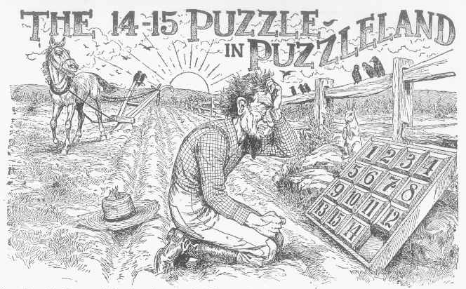  
The picture above shows the original advertising for Loyds puzzle, where the 14 and 15 pieces can be seen to be swapped.

Whilst for this amount of money it may seem an easy challenge it was actually proved over a decade later after many claimed successes and failed attempts that the puzzle was in fact impossible. But that didn’t matter, this puzzle had shown for the first time just how popular a past time could be, nothing before it had shown such captivation in the public.

Permutation puzzles then took a hiatus through the early 20th century, puzzles such as crosswords and games took over in the public eye until a Hungarian architect and sculptor set himself a challenge.

Erno Rubik was working at the Budapest academy of applied arts and design as a lecturer in interior design where he enjoyed coming up with new structures which would make his students think in new ways about 3d form, it was here that rubiks posed himself the challenge of coming up with a way to allow blocks to move independently of each other without falling apart, this was the idea of the eubiks cube. His initial attempt at using rubber bands failed leading him to come up with the solution of hooking shapes to hold themselves together. He later applied coloured stickers to each side to see how each piece moved.

When asked about the first moment Rubik himself turned the cube he said "It was wonderful, to see how, after only a few turns, the colors became mixed, apparently in random fashion. It was tremendously satisfying to watch this color parade. Like after a nice walk when you have seen many lovely sights you decide to go home, after a while I decided it was time to go home, let us put the cubes back in order. And it was at that moment that I came face to face with the Big Challenge: What is the way home?"

After much attempt at putting the colours back he soon realised random turning would get him nowhere and so he sat down to try and come up with a method, after a month of trying he finally resolved the cube, and it was at this point he realised its potential as a puzzle.

In 1974 Rubik came to an agreement with Hungarian toy manufacturer Politechnika who would produce the cube as a puzzle, known as the Büvös Kocka

Or the ‘magic cube’ it was in this year that Rubik filed for his first patent. By March 1977 he received confirmation of the Hungarian patent HU17006 and the cubes were starting to pop up in Budapest toy shops. In 1979 a deal was struck with the ideal toy company to start sales of the cube internationally and its big break came with the Nuremburg, London and New York toy fairs of the early 80’s when it became the mega fad we know it to be.

As with all great business ventures the rise to fame of the Rubiks cube didn’t come without its difficulties, in 1980 when Rubik applied for an international patent for his cube he was denied it, due to the fact of international patent law that you are not able to apply for an international patent a year after your national patent. This left the cube open to imitations, of which there were many, trying to piggyback on the fame of the cube. This however ended up being beneficial for Rubik and the ideal toy company as to try and get some trademark protection they changed the name of the puzzle to that of its inventor, and it was cast in puzzle history as the Rubiks cube.

The puzzle continued to grow in popularity making Rubik the first self-made millionaire in the communist bloc, he continued to make other puzzles including the Rubiks Snake and various size alterations of the original cube. It has since become a cultural icon appearing in many places throughout the past decades and inspiring many other versions and even competitions to see how fast the puzzles can be solved. Until now no other toy has been as popular as the Rubiks cube whos sales trump any of the modern technology we see on the market nowadays. Also unlike Sam Loyds fifteen puzzle the Rubiks cube is actually possible , just really really difficult.